The completion of Part 1 of this project (from Week 4) will be your starting point. You will create a new version, adding an external style sheet to add color styling.

*This Website project continues throughout this course and will be graded twice (midterm and final). You will be given instructions to build the website along with what you have learned for the week.  Stay on top of this project!  This is a weighted project worth a total of 50% of your grade.*

STEP 1 – Create a folder called <lastname> ArtWorks2. Add in the folder, copies of the index and art html files from PART1’s ArtWorks folder.

STEP 2 – Using a text editor, create an external style sheet named artworks.css. Review the sample wireframe of your home page:

header

nav

main

div

footer

body

Code CSS to configure the following:

1. Add global styles for the document (body element) with a brown background color (#4B433A) and gray (#A19688) text color.
2. Code the header element selector with a background color. Use #f6f4f7.
3. Style for the footer element selector is a background color of #FFFFFF.
4. Save your CSS file. Check your syntax with a CSS validator. (Recommend: <https://jigsaw.w3.org/css-validator/validator.html.en>). Correct and retest if needed.

STEP 3 – Open your home page (index.html). Add a <link> element to associate your artworks.css cascading stylesheet in the head section. Save and test your index.html page in a browser.

STEP 4 – Open your art page (art.html), and add the CSS file link to the head section. Save and test your art.html page in a browser.

The styles should be applied as shown in this example:

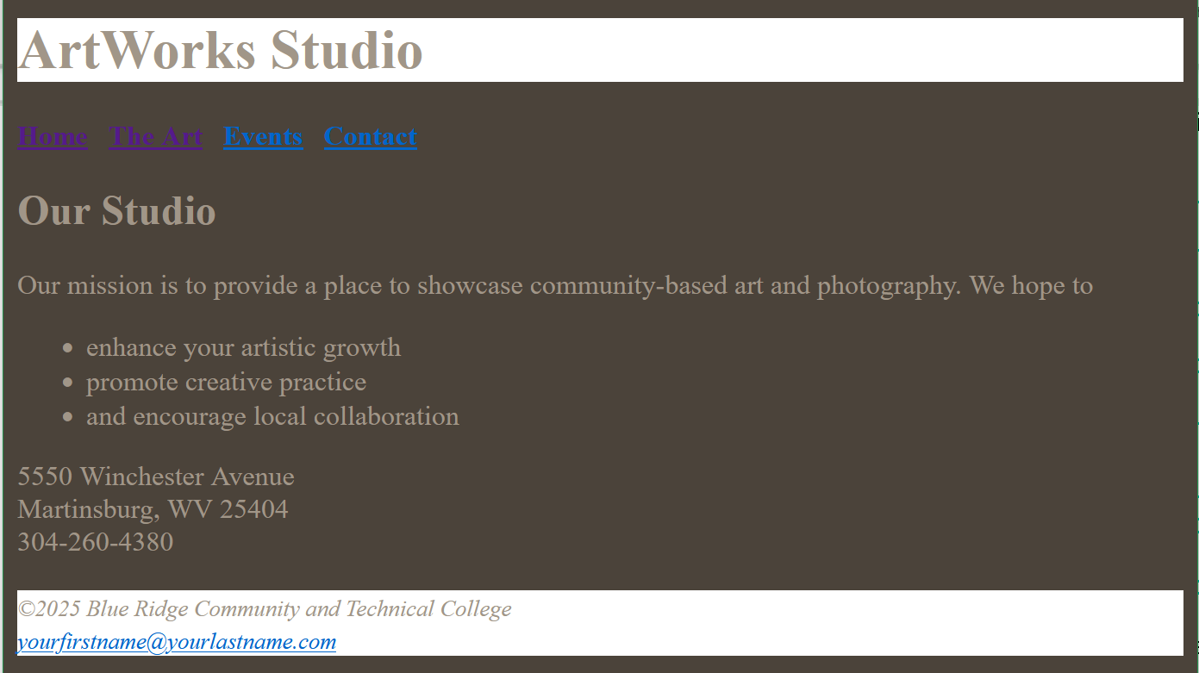 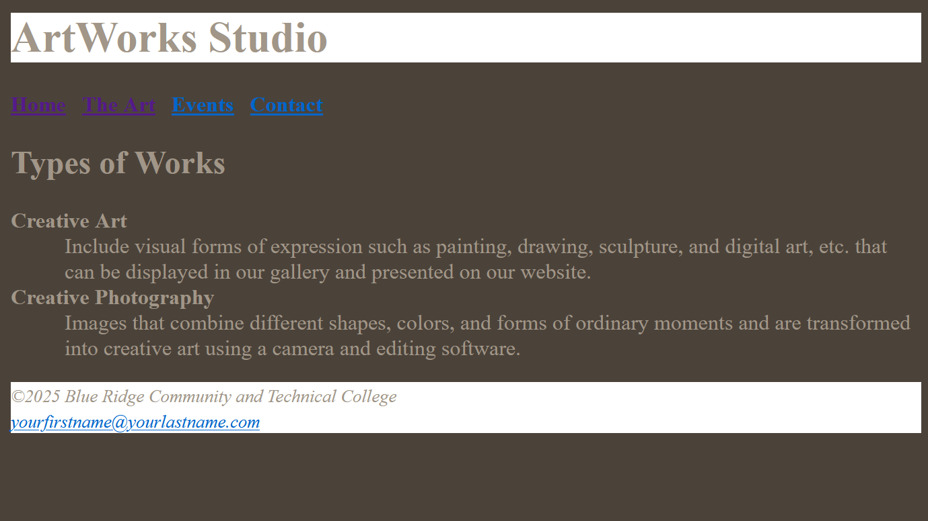

STEP 5 – Add the awheader.png and aw1.png images files provided with this project’s instructions to your Artworks2 folder.

STEP 6 – Return to you the artworks.css file in your text editor and add the following:

1. Add a declaration that configures Trebuchet MS, sans-serif font typeface to the body element.
2. To the header element selector, configure the image awheader.png as the background image that displays to the right without repeating.
3. Configure the nav element selector styles aligned centered with bold text.
4. Add a nav a element selector (a descendant selector) and code style to eliminate the display of the underline for hyperlinks.
5. For the h1 element, add its selector and styling to display 300% line height and 1em left padding for the text.
6. Add declarations to the footer selector for small, italic, and centered text.
7. Create a (list item) li element selector with 90% font size, and
8. do the same for the (description) dd element selector (90% font size).

Use the CSS validator to test your syntax. Correct and retest if necessary.

STEP 7 – In your text editor, go to your home page index.html.

1. Remove the bold, small, and italic element tags since these are not covered with the cascading stylesheet.
2. Add an image element above the heading 2 element. Configure the img tag to display aw1.png. Add attributes to configure the alt text “Visitor viewing art.”, and height and width at 200px. Also have the image appear right using the align=”right” attribute.

STEP 8 – Go to the art page (art.html) in your editor and remove the bold, small, and italic element tags.

Example of ArtWorks with text styles, some layout added, and images added:

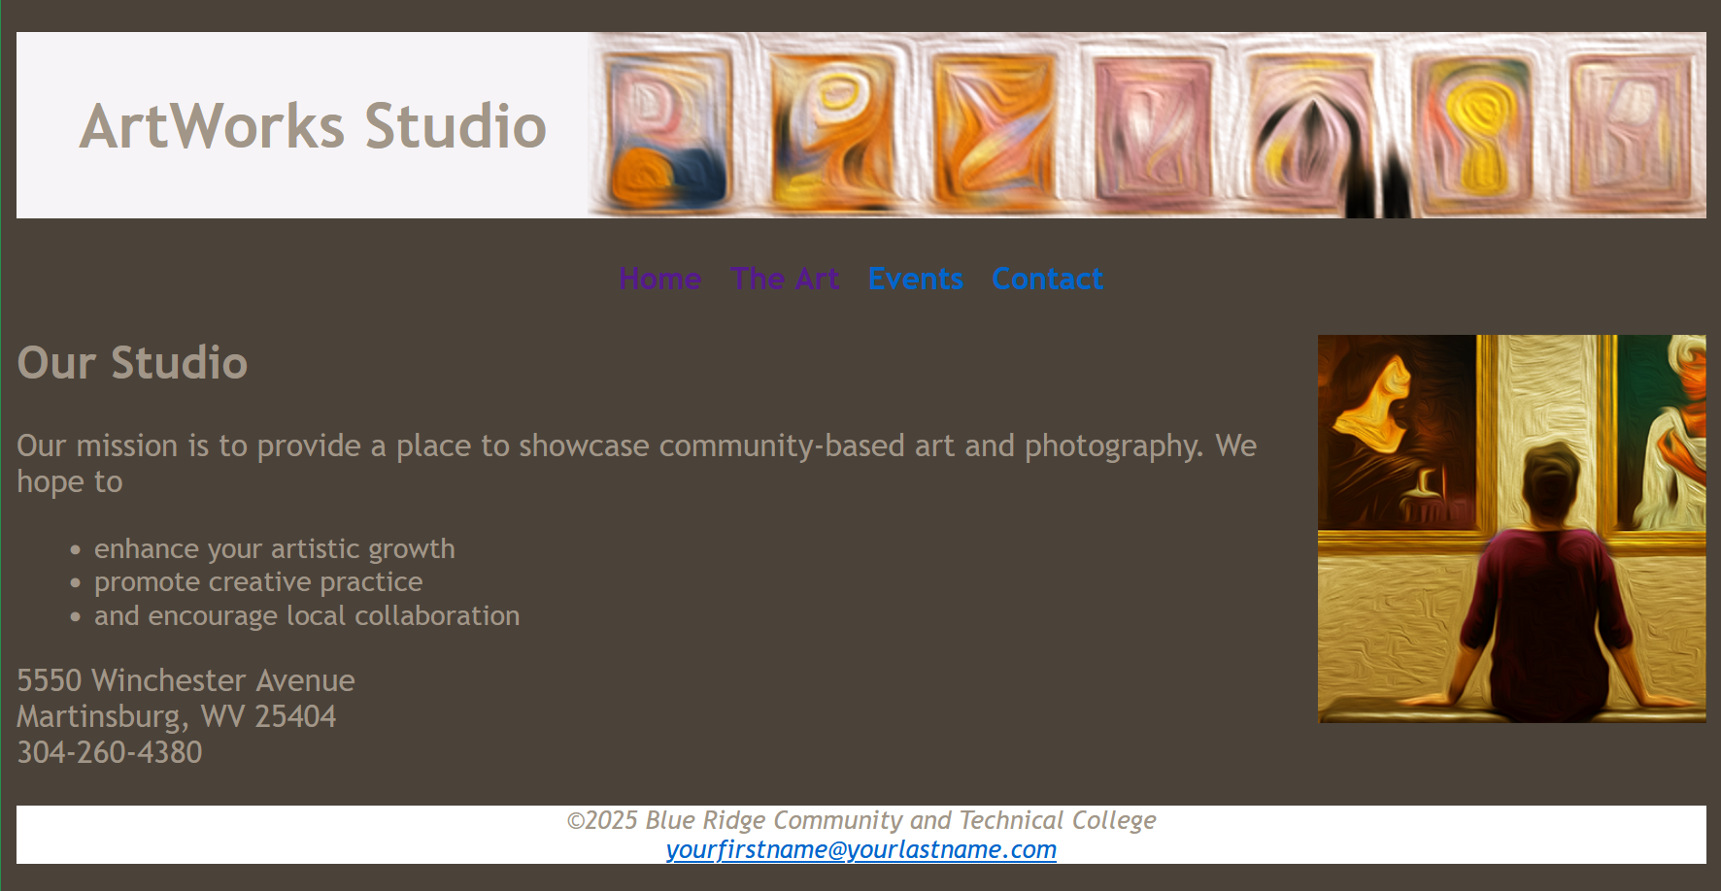

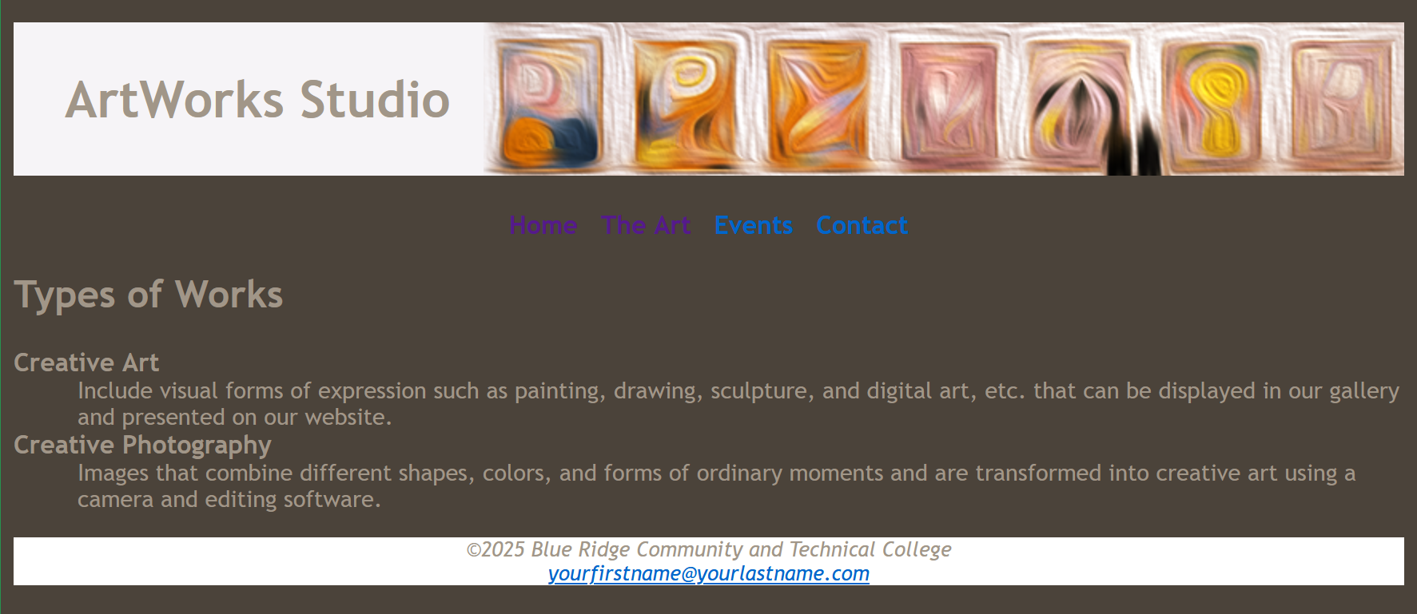

Save your website files and test the site in a browser. Verify the folder name, file names, and all content are punctuated and spelled correctly.

REMEMBER: This project is ongoing and will first be submitted at midterm for grading. You will receive additional building instructions up until then and after midterms, you will continue to build upon the site with the complete project submitted during finals.

Contact your instructor, with any questions regarding these directions.